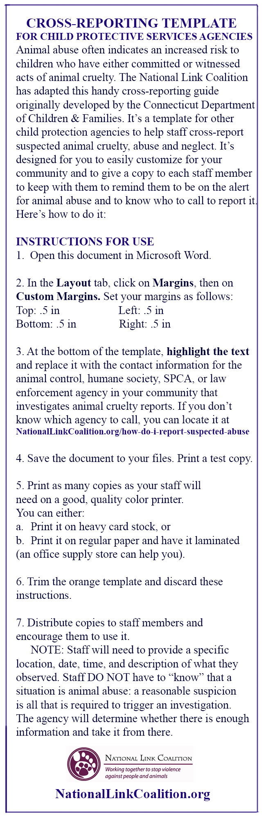

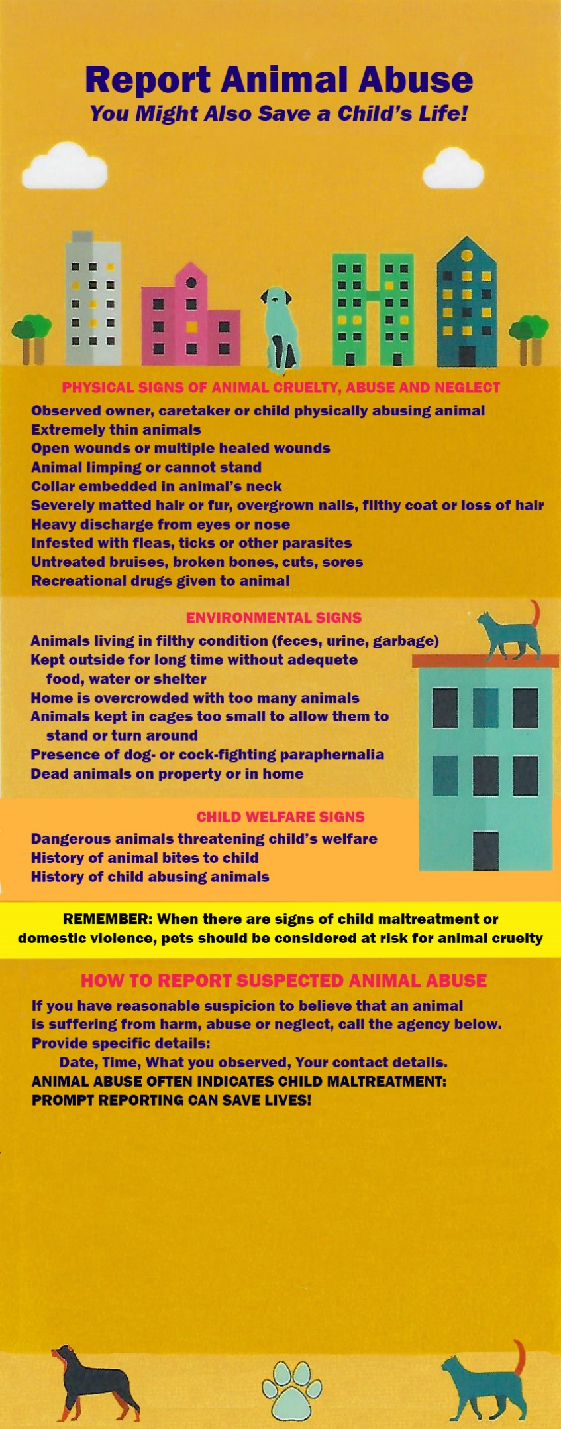

Highlight this text and replace it with the name and
phone number of the animal abuse investigation
agency in your community. If you don’t know who
it is, you can find it at
nationallinkcoalition.org/how-do-i-report-suspected-abuse

You can add the name of your organization HERE.

